Common What If Scenarios and How to Adjudicate Them

Illegal Pitch 6-2 (Pg 53 RB, Pg 44 CB)
Runner Leaving Base Early 8-6-18 (Pg 72 RB, Pg 70 CB)
Batting Out of Order 7-1 Articles 1 & 2 (Pg 57 RB, Pg 47 CB)
Illegal Substitute 2-57-3 (Pg 29 RB)
Unreported Substitute 2-57 Article 2 (Pg 28 & 29 RB, Pg 32 CB)
Look Back Rule 8-7 (Pg 72 RB, Pg 70 CB)
Field Not Set Up Correctly Rule 1-1 (Pg 7 & 8 RB, Pg 5 CB)
- Batter’s Box
- Plate or Bases Off Center
- Foul Lines Crooked
- Double Base Incorrect Color or Dimension (Pg 10 RB, Pg 6 CB)
Pitchers Plate at the Incorrect Length 1-2-3 (Pg 10 RB, Pg 5 CB)
Dropped Third Strike 8-1-1b (Pg 62 RB, Pg 53 CB)
Two Runners Occupy the Same Base at the Same time 8-4-7 (Pg 66 RB, Pg 59 CB)
How Many Warnings Does a Coach Get?
A Restriction or Ejection

Illegal Pitch 6-2-1
What is an Illegal Pitch?
- Pitcher violates the pitching rules
- Fails to pause 1 second or more than 10 seconds upon stepping on the “Pitchers Plate”.
- Not removing themselves from the Pitchers Plate properly.
- Fails to maintain contact with the Pitchers Plate with the pivot foot prior to releasing the ball.
- Fails to maintain ground contact with the pivot foot (Airborne) with both feet off the ground at the same time.
- Pitchers starts or steps outside the 24” length of the Pitchers Plate during the pitch.
Once an Illegal Pitch is ruled by either the Plate or Base Umpire the umpire will give the Dead Ball Signal and verbalize “Illegal Pitch” so that the closest participants around them can hear it.
Once the play is over determine the results of the Illegal Pitch.
Coach Has No Option:
- If the batter does not swing and the pitch is a strike it is changed to a ball and if this results in Ball Four the Batter is awarded 1st Base and all runners are advanced if forced.
- If the batter swings and hits the pitch and gains 1st Base and all runners on base advance at least one base the Illegal Pitch is NULLIFIED, and results stand.
Coach has an Option:
- If the batter swings and hits the pitch and gains 1st Base but all runners do not advance at least one base, or the Batter fails to obtain 1st Base then the Offensive Coach will be given the option of accepting the results of the play or accepting the penalty for the Illegal Pitch.
THE ADVANCING OF RUNNER(S) FOR AN ILLEGAL PITCH NO LONGER EXISTS! DO NOT BE THAT ONE…

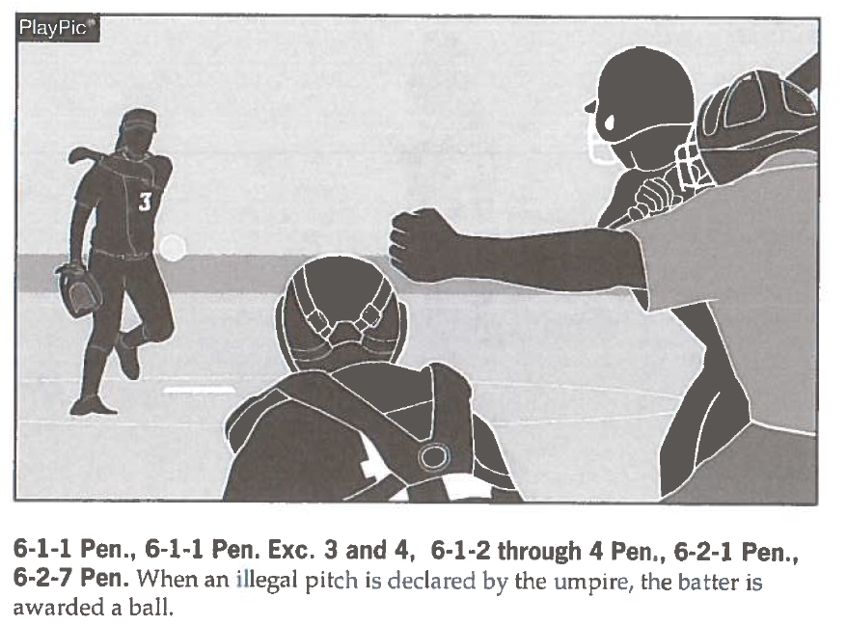

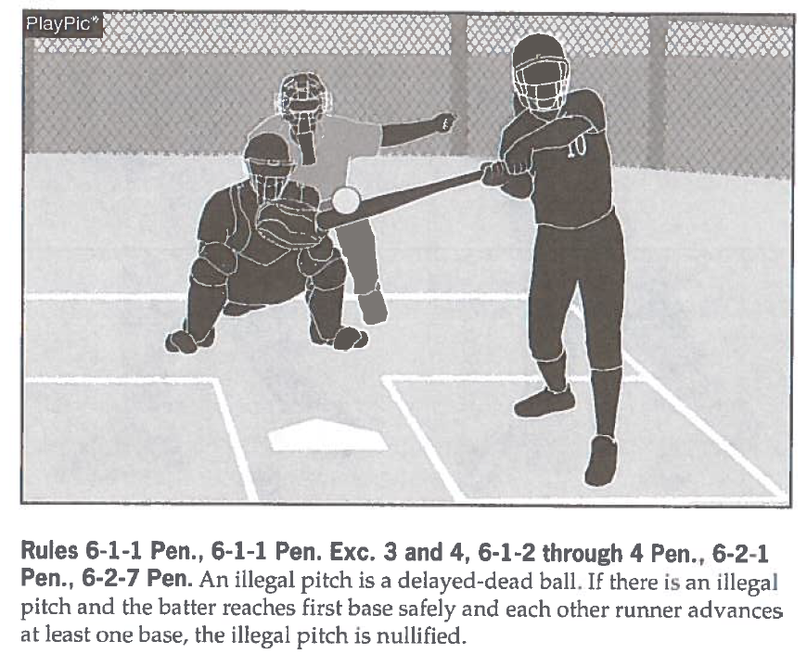
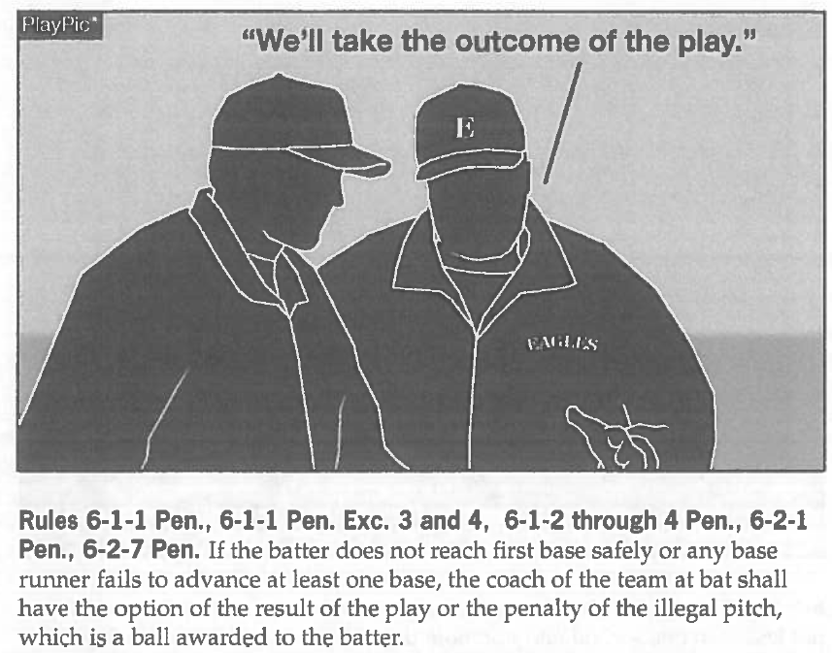

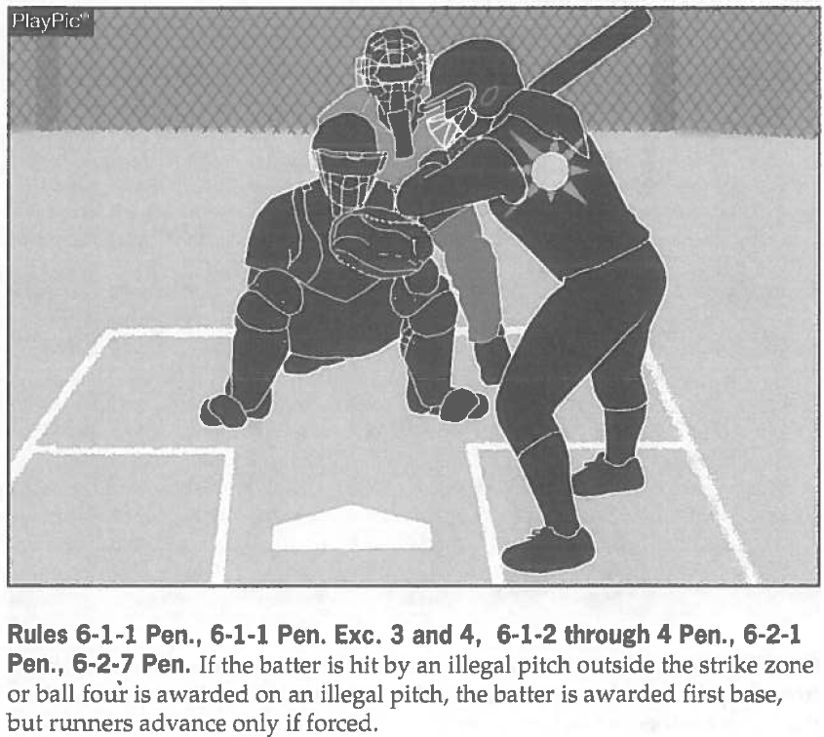

Runner Leaving Early 8-6-18

What is leaving the base early?

Runner loses contact with the base they’re on prior to the ball leaving the pitcher’s hand.

Once a base umpire determines that the runner leaves early the umpire will announce “No Pitch” while signaling Dead Ball. The Base Umpire will then say Runner is out for leaving early. If the ball was pitched the Plate Umpire will repeat the previous count as if that play had not taken place.
If you have multiple runners and they both leave early you can only call one of them out and the other is returned to base.
Observe the runners and if you notice them close to leaving early use some preventive officiating. I always let them know that they need to work on timing it better. This lets them and sometimes their coach know that I’m watching them.
Don’t be afraid to make this call if the runner is gaining an advantage over the Defense.

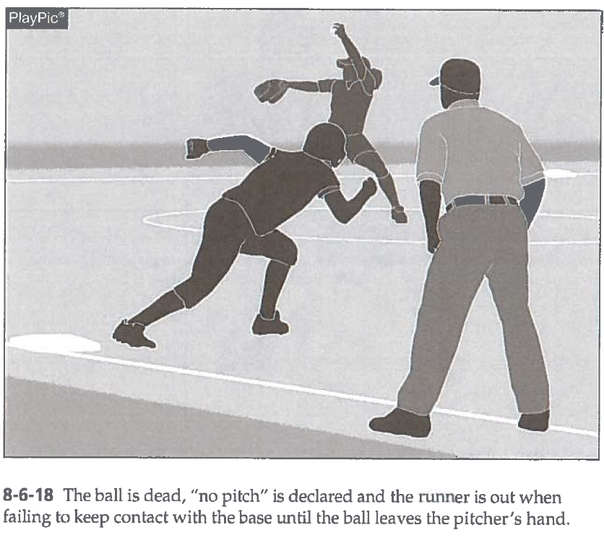

Batting Out of Order 7-1, 1 & 2
What is Batting Out of Order?

Batting out of order is where a batter in the lineup has taken position in the batter’s box out of the set lineup that was turned into the Plate Umpire at the Pre-Game Conference.

If a batter is found to be out of the set order while they are still at bat, then the correct batter will be placed in the batter’s box and the batter will assume the current count of the batter.

If the batter that batted out of order gets on base and prior to the next pitch legal or illegal the DEFENSIVE COACH brings the infraction to the Plate Umpire shall declare batted out (NOT THE IMPROPER BATTER). The improper batter’s time at bat is negated and the batter-runner is returned to the dugout/bench area. ALL OUTS stand and runners who were not declared out must return to the base occupied at the time of the pitch. If a runner advances because of a stolen base, wild pitch, or passed ball (F.P.) while the improper batter is at bat, such advances are legal.
If after a pitch illegal or legal has been thrown then the runner on base will be the runner of record. If the runner on base is the batter that is supposed to be up, then the batter that follows them will be the next batter.

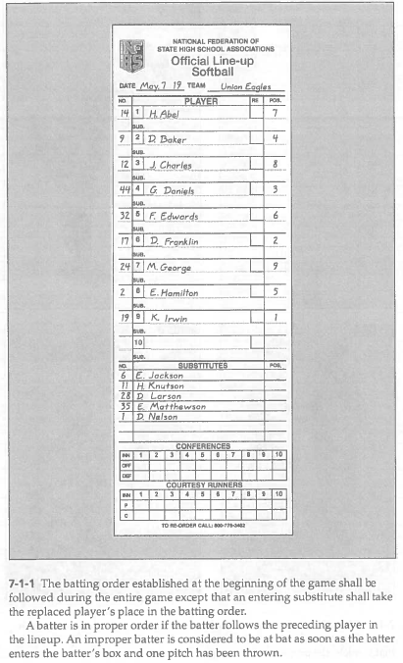
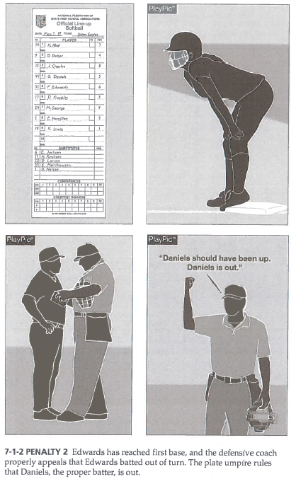
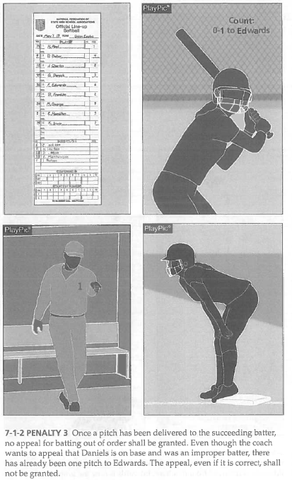
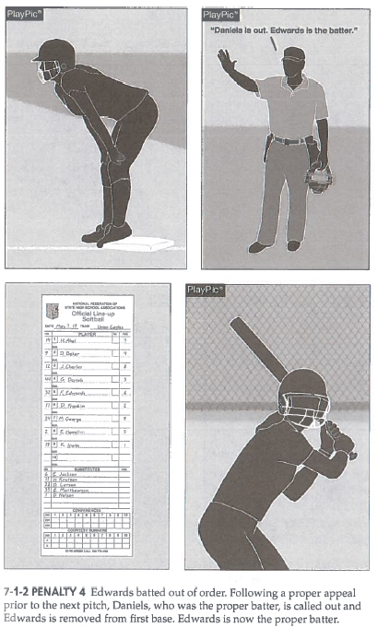
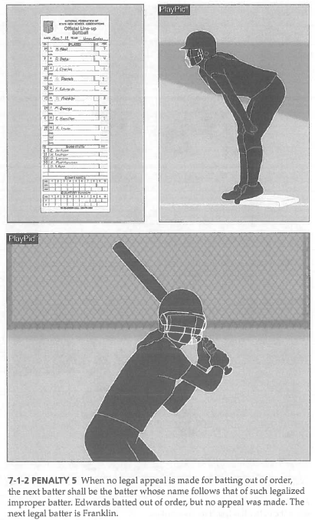

Unreported Substitute 2-57-2

What is an unreported Substitute?

An unreported substitute is a substitute who has legal right to participate in the game but has not reported to the Plate Umpire prior to participation (3-3-4, 3-6-7). All substitutes must be reported to the Plate Umpire.
The penalty for an unreported substitute is the player is placed into the game and the line up card adjusted to show the correct line up. The Coach receives a warning and if this is the second warning then they are restricted to the dugout.

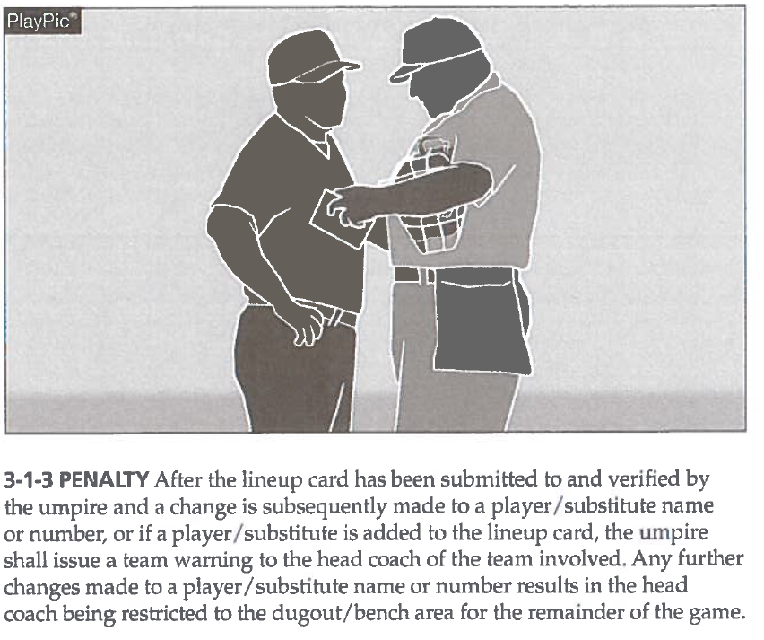
Illegal Substitute 3-4, 1 & 2

What is an Illegal Substitute?

An illegal substitute is a player who enters or re-enters the game without eligibility to so (illegal re-entry); a player who re-enters the game in the wrong position in the batting order; (F.P.) the Flex who enters the game as a batter or runner in a different position in the batting order than the DP; or a player who violates the courtesy runner rule.
Article 1… Illegal Offensive or Defensive players may be discovered by the umpire or either team anytime after the ball becomes live and an illegal substitute has taken position as:
- A runner the illegal substitute has replaced or as a batter in the batter’s box;
- A pitcher on the pitcher’s plate, or as a fielder reaching a position usually occupied by the fielder being replaced; or
- A courtesy runner if that player has violated the courtesy runner rule.
Penalty: Restricted to the dugout/bench for the remainder of the game (a & c the runner is also called OUT).

OFFENSIVE PLAYER

Article 2… Illegal offensive players may be discovered:
- When in the batter’s box, the ball is live and/or dead before the batter-runner reaches first base, or is put out and before a pitch is delivered to the next batter of either team;
Penalty: The Player is called out and restricted to the dugout/bench the remainder of the game, the proper batter is considered to have lost their turn at bat. The next proper batter shall bat

- When the illegal batter-runner or runner advances, scores or causes a play to be made that allows another runner(s) to advance or score, and the infraction is detected before the next pitch by either team;
Penalty: The Player is called out, the play is nullified, outs made on the play stand, runner(s) not put out return to the base(s) occupied at the time of the pitch and restricted to the dugout/bench the remainder of the game.
- When an illegal batter-runner or runner advances, scores or causes a play to be made that allows another runner(s) to advance or score, and the infraction is detected after the next pitch by either team;
Penalty: If the Player is still on base, the player is called out, the play stands, and restricted to the dugout/bench the remainder of the game.

- In a game-ending play prior to all infielders and/or umpires leaving the diamond.
Penalty: The Player is called out, if the player is still on base, the player is called out, the play is nullified, outs made on the play stand, runner(s) not put out return to the base(s) occupied at the time of the pitch and restricted to the dugout/bench the remainder of the game.

NOTE: The penalty for Illegal Substitution takes precedence over the batting-out-of-order penalty.

DEFENSIVE PLAYER
Article 3… Illegal defensive player is discovered before the next pitch to either team:
- Involved in a play with a batted ball;
- Anon-batted ball is handled or touched by an illegal substitute that leads to a runner being put out;
- A non-batted ball is handled or touched by an illegal substitute that alters the play, but no runner is put out (i.e. on an overthrow on a stealing runner, the illegal substitute retrieves ball and prevents runner from advancing farther).
Penalty:
- The illegal player/substitute shall be restricted to the dugout/bench for the remainder of the game. (Art. 3a, b) Team on offense has the option of taking the play or accepting the penalty (out is nullified, runners return to base occupied at time of pitch.) (Art. 3c) Umpires may award bases based on their judgement and the circumstances concerning the play. (Art. 3a) The batter is allowed to bat again with the same count. (Art. 3b,c) The pitch is canceled if it is a strike or stands if it is a ball.
- After another pitch, all play stands but the illegal player/substitute is still restricted to the dugout/bench for the remainder of the game.
- Any time a non-batted ball is handled or touched by an illegal substitute and does not lead to a runner being put out or alter a play, the play stands and the illegal substitute is restricted to the dugout/bench.

Look Back Rule 8-7
What is the Look Back Rule and when does it take effect?

The Look-Back Rule will be in effect when the ball is live, the batter-runner has touched first base or has been declared out, and the pitcher has possession of the ball within the pitcher’s circle. (2-45)

The runner(s) may stop once, but then must immediately return to the base or attempt to advance to the next base.
Once the runner stops at a base for any reason, she will be declared out if she leaves the base.
Responsibilities of batter-runner after completing a turn at bat, and while the pitcher has the ball within the 16-foot pitching circle, including a base on balls or a dropped third strike are as follows:

- A batter-runner who rounds first base toward second base may stop, but then must immediately, without stopping, return to first or attempt to advance to second base.

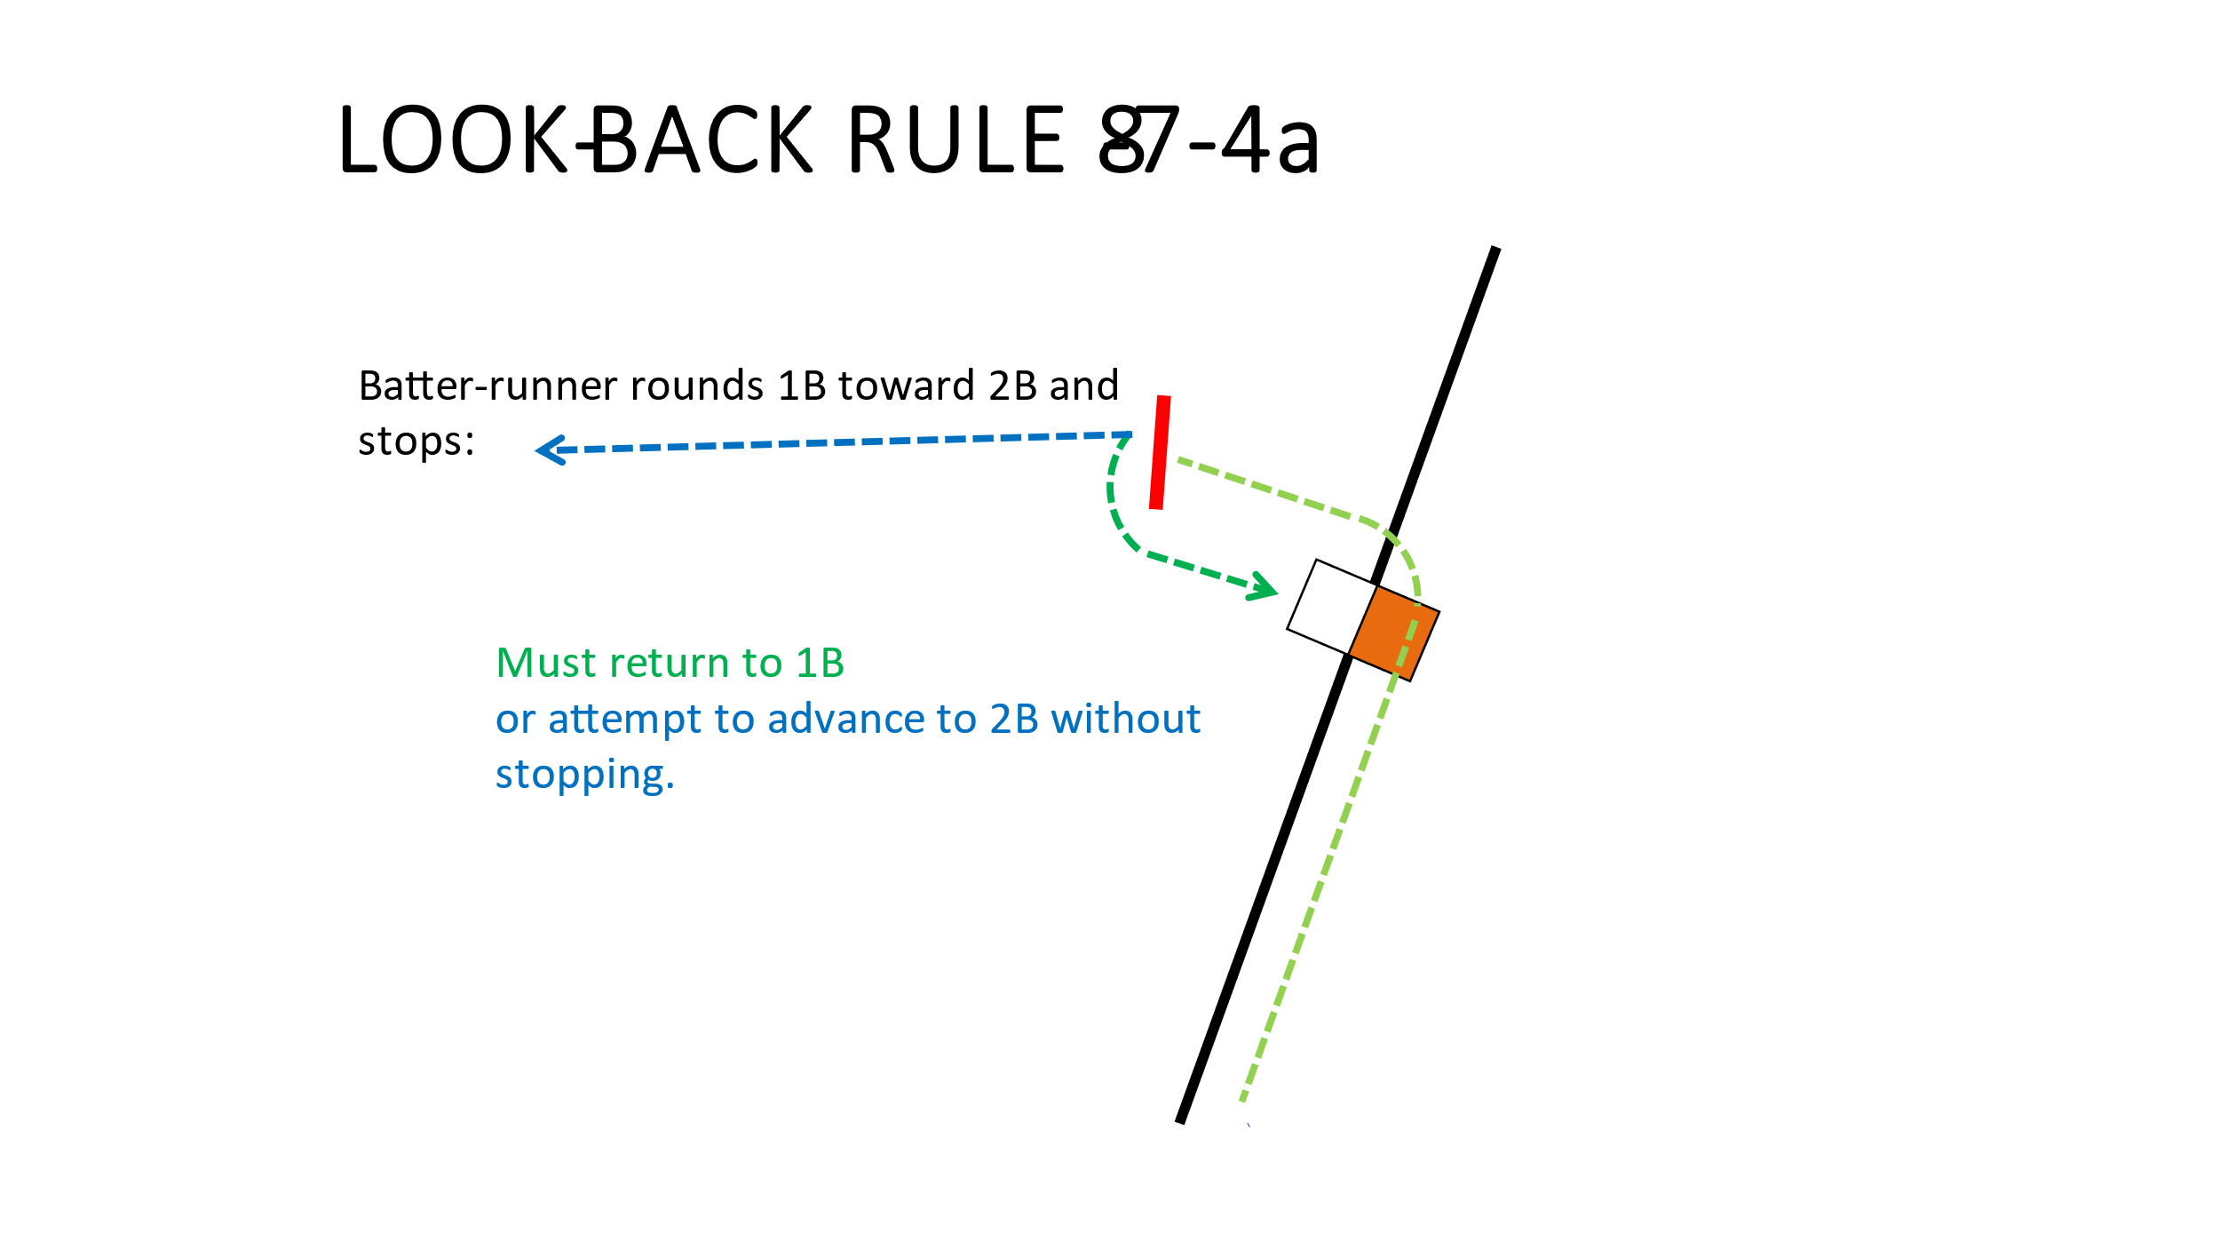

- A batter-runner who overruns first base toward right field, turns left and immediately stops, must then return non-stop to first or attempt to advance to second base.

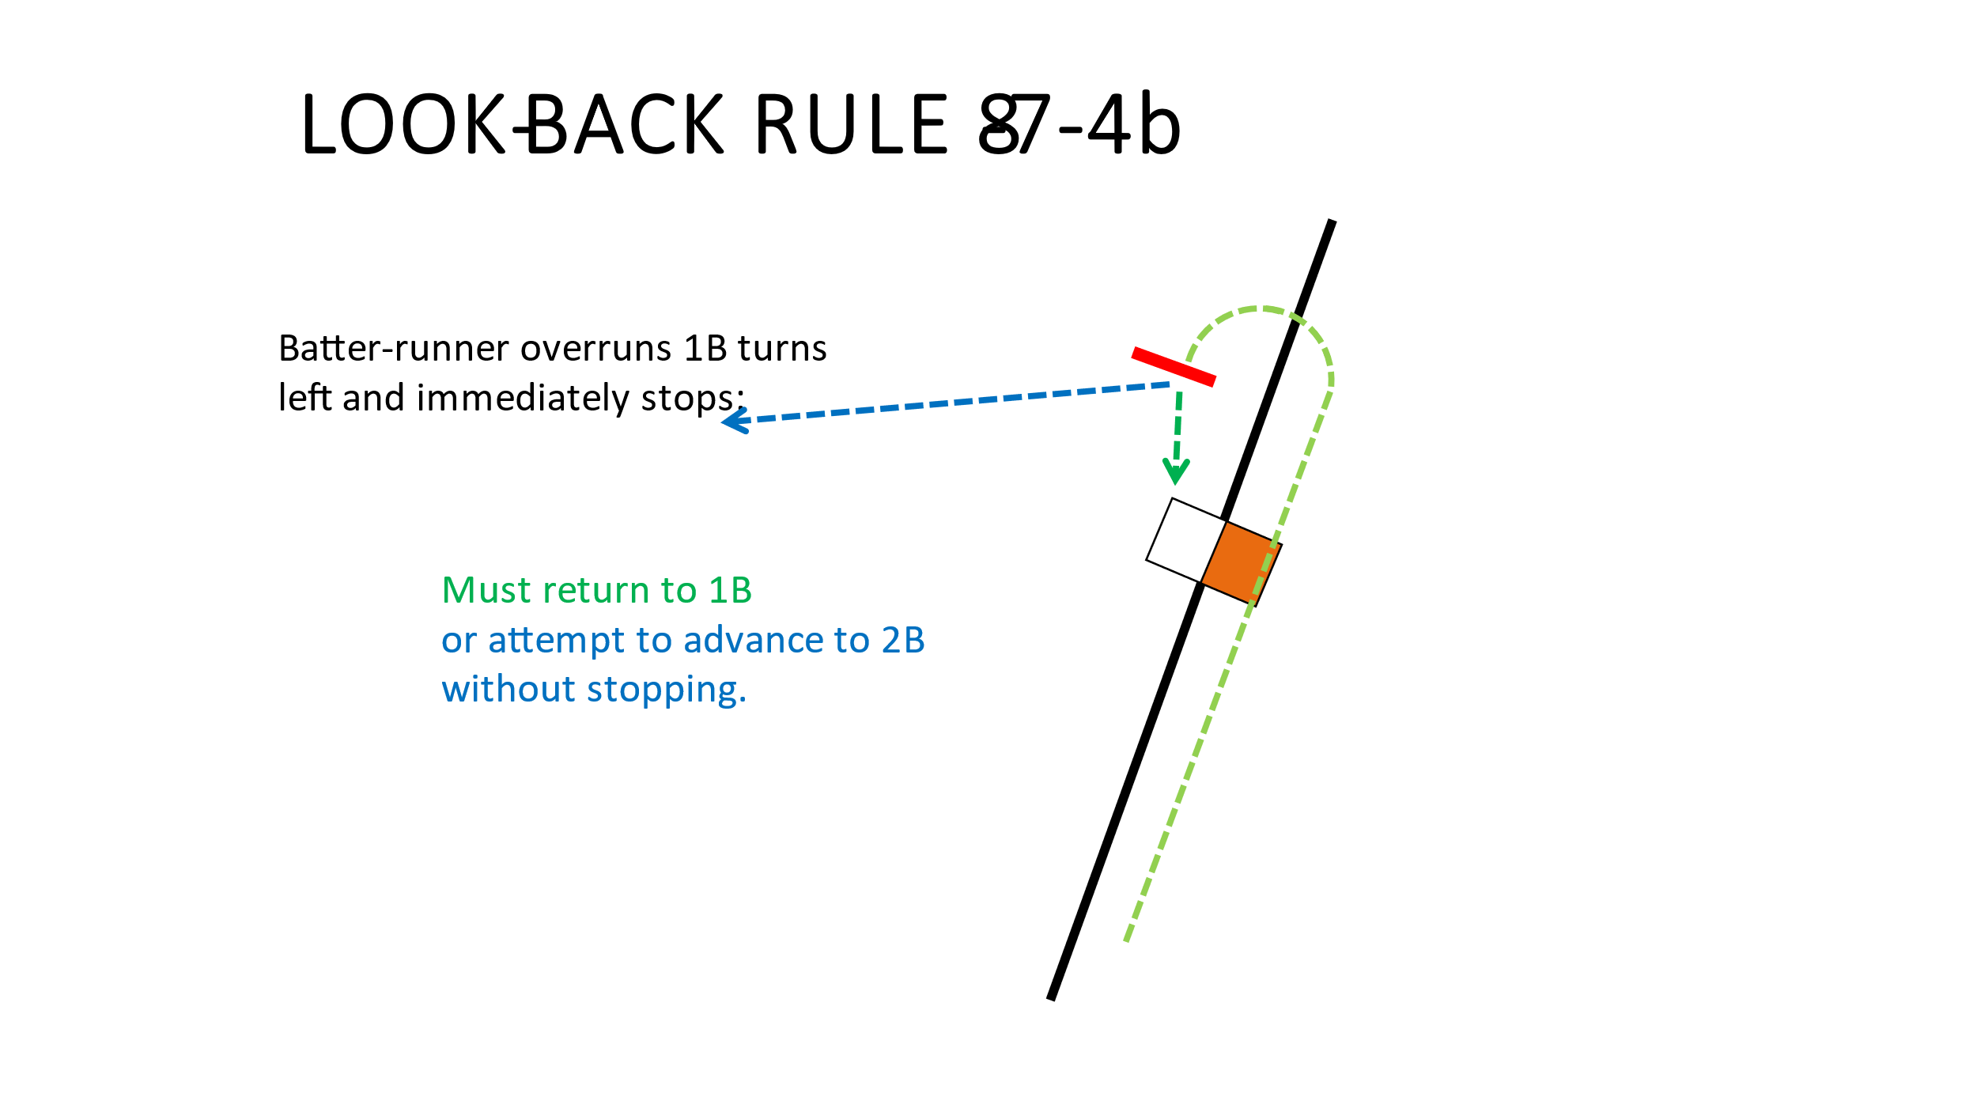
- A batter-runner who overruns first base toward right field, turns left and moves directly toward second base and stops is committed to second and must attempt to advance non-stop to second base.
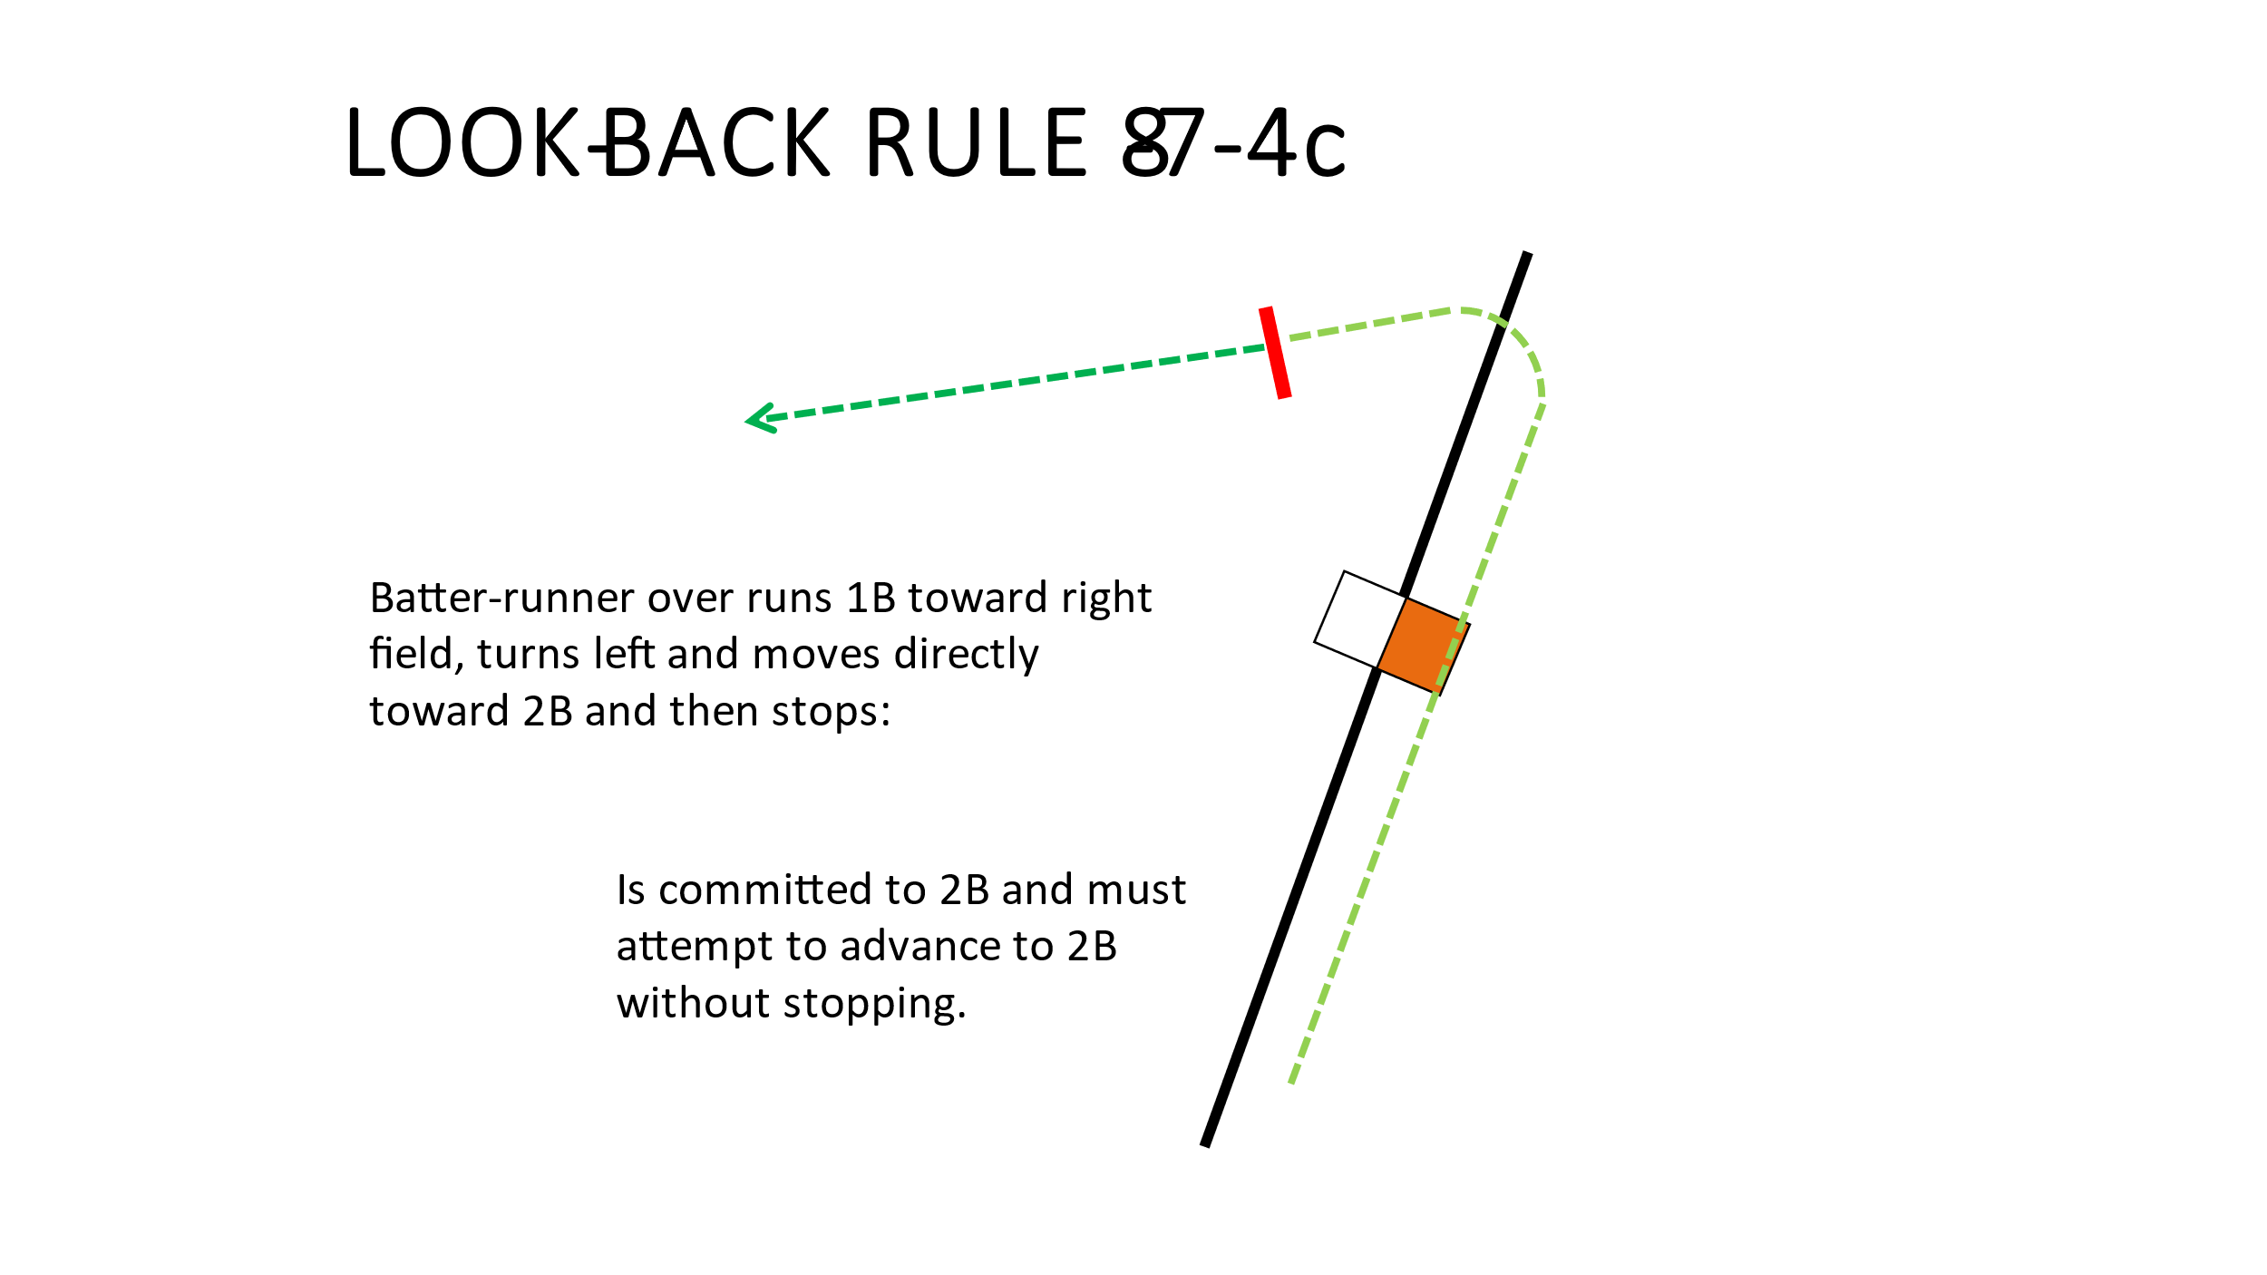
d. A batter-runner who overruns first base toward right field, turns left and moves back toward the infield in any direction except directly toward second base is committed to first and must return to first base.
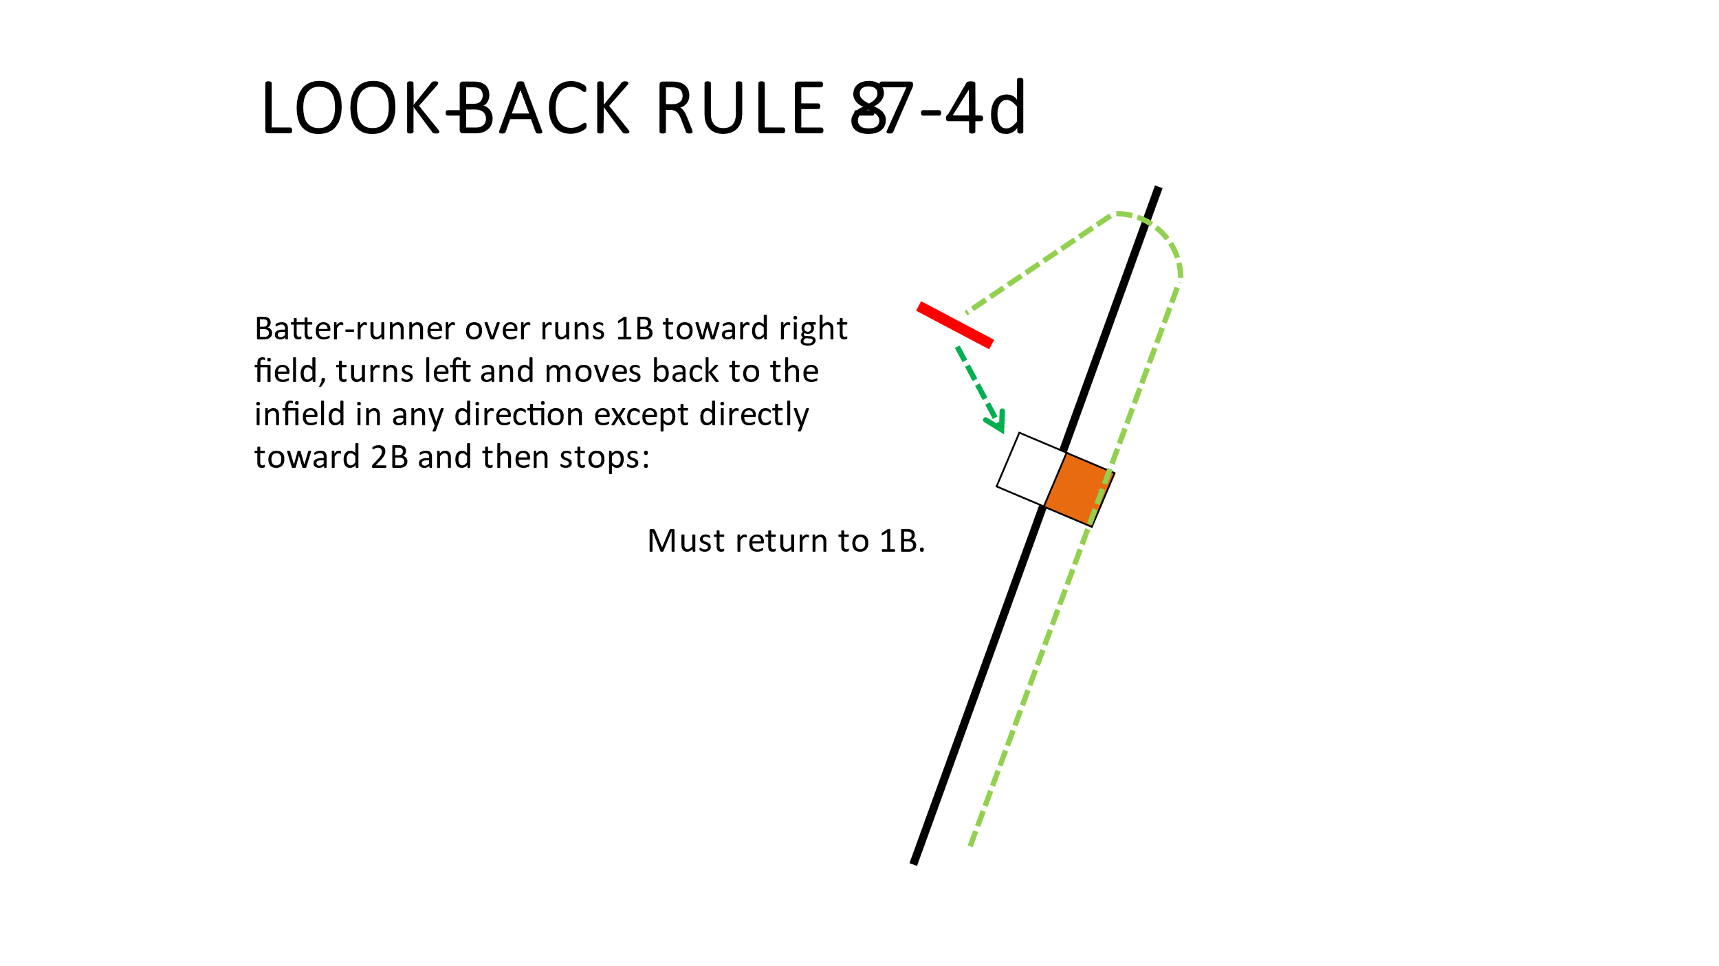
e. A batter-runner who overruns first base toward right field, and turns right, is committed to first base and must
return to first base.
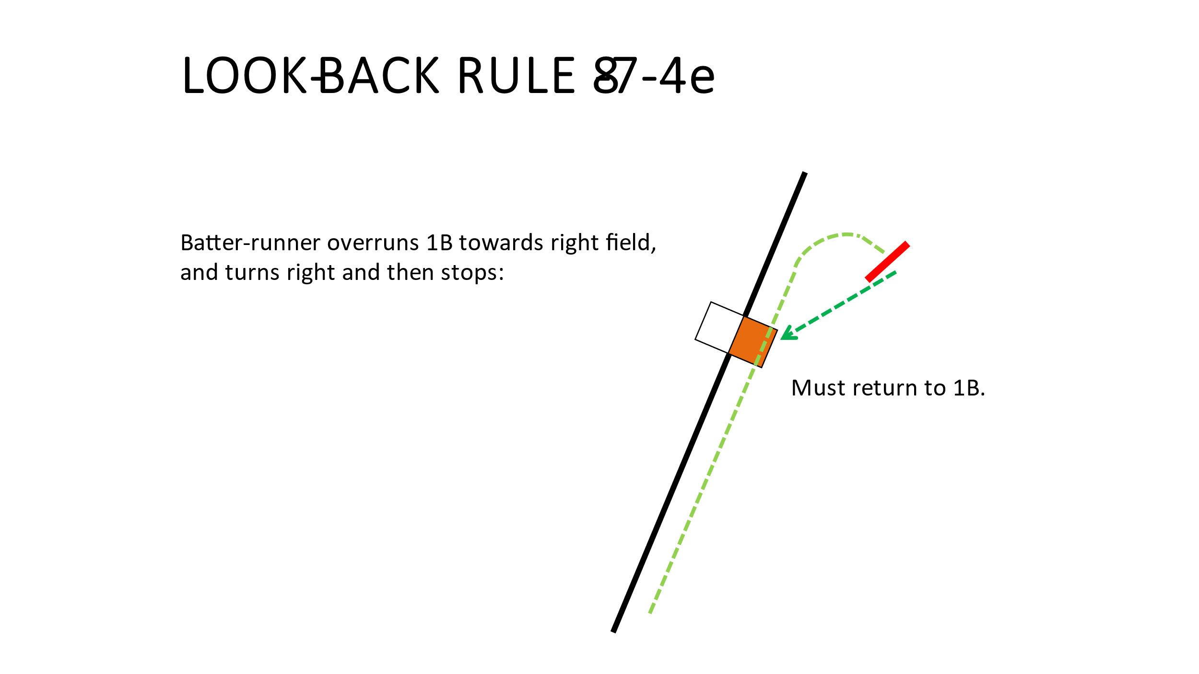
The ball is dead. "No pitch" is declared when applicable, and the runner is out. If two runners or more are off their bases, when one is called out, the ball is dead and other runners are returned to the last base touched. Only one runner may be called out.
EXCEPTION: The runner will not be declared out if a play is made on another runner (a fake throw is considered a play), the pitcher no longer has possession of the ball within the 16-foot circle, or the pitcher releases the ball on a pitch to the batter.

Field Not Set Up Correctly
What do you do when you show up to a site and the field is not marked correctly or you notice that the Home Plate and Pitchers Plat and the Second Base are not lined up?
Get with the home coach and see if the corrections can be made in a timely manner if at all.
At the Pre-Game Meeting go over discrepancies and then decide if the coaches are willing to continue play with the known discrepancies.
If both coaches agree then play on and call the game by the way the field is laid out.
If you need to adjust a batter’s box line or two, make the correction and remind coaches that this is what we’re playing by tonight.

Pitchers Plate Discovered to Be Incorrect 1-1-9
At any time throughout the contest, it is brought to the attention of the umpires that the pitching plate may be at an incorrect distance. The game is stopped, and the pitchers plate distance is checked and if found to be off it is corrected right then. The game is resumed from the point of the interruption. You do not wait until the completion of the bottom of the inning, it is corrected immediately, and play resumed from the point of the interruption.

The Safety Base is the Wrong Color or Size
If during your inspection of the field, you notice that the Safety Base is White, or it is a different dimension than the First Base what do you do?

- If the First Base and the Safety Base are one, then not a lot can be done other than noting the issue and alerting the chapter leadership. “DO NOT COMPLETE AN INCIDENT REPORT UNLESS TOLD TO DO SO BY THE CHAPTER LEADERSHIP”
- If First Base and the Safety Base are separate, then have the Safety Base removed and ensure that the hole is plugged. If this cannot be accomplished, then revert to 1 above.
- A Safety Base is not required but if it is present on the field then it is used.
- Safety Bases must be the same dimensions as First Base.
- Safety Bases must be another color than WHITE.
Remember that the runner is required to use the Colored Base (Safety Base) and the fielder is required to use the White Base (First Base). Except
- The play takes the field into foul territory, and they make the play using the Safety Base.
- Catcher secures a past ball toward the foul side of first base the fielder is allowed to set up in foul territory and the runner is required to use the First Base.
Note: Once the runner obtains first base the safety base and the first base become one.

2 Runners Occupying the Same Base
When you have two runners occupying the same base always remember that the runner that was originally occupying the base is safe and the runner that is moving toward the base is out if tagged even though she may be in contact with the base. Its tricky and the coaches will try to talk you into two outs, but it is not. The runner that occupied the base is the owner of the base unless they willingly leave it.

Catch/No Catch of a Dropped Third Strike
For the catcher to have a catch of a pitch it must be caught and controlled.
If the pitch hits the ground on a swinging or called third strike the batter is allowed to attempt to first base if there are less than 2 Outs and First Base is not occupied at the time of the pitch. If there are 2 Outs, then the batter may advance even if First Base is occupied.

How Many Warnings May a Coach Receive?
If you warn a coach for an infraction during the contest the next infraction by the coach or even their team in some instances will require you to notify the coach that they are restricted to the dugout.

What can a coach DO when they’re restricted to the dugout?
- They may continue to coach from the dugout
- They may be beckoned onto the field to administer to an injured player
- They may be out and in front of their dugout for the meetings between innings

What can a coach NOT DO when they’re restricted to the dugout?
- They may not coach a base
- They may not come out and challenge a call

If after you have restricted a coach or player to the dugout/bench and they continue to interrupt your game what are your options?
Coach is ejected and must leave the confines within a brief amount of time or subject their team to a forfeit. After the coach departs the confines then and only then you will resume the game. (Make sure that you make notes for your conversation with 2 Members of the Executive Leadership of the chapter).
If it is a player and the coach can not control them, they will need to leave the confines of the field with an escort (Coach or Adult Team Member (Non Playing)) and they too have a brief time frame to make this take place.
Make sure you make good notes on any Restriction or Ejection because you may need to complete an Incident Report.

Last thing exercise PROFESSIONALISM, SOUND RULES KNOWLEDGE, and COMMON SENSE when officiating and you’ll be able to work through anything you incur on the field.
If you do not know the rule between the two of you than you will need to make a decision and be prepared to live with it….
Partner(s) keep your partner out of trouble provided you can.

